­­

**Do you want to Stop Smoking?** 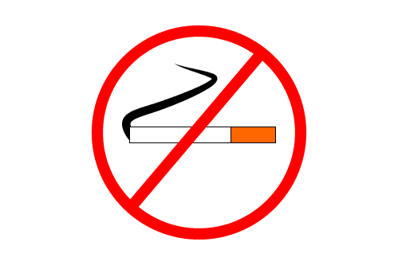

**The Surgery has a Stop Smoking Clinic here so**

**if you would like to make an appointment please see the reception staff**

**Benefits from Stopping Smoking:**

* More Energy
* Less Stress
* More Money
* Younger Looking Skin
* Live Longer

