The Limes Medical Centre
New Registrations
When registering at The Limes Medical Centre, please bring with you: -
ONE PROOF OF ADDRESS
The Surgery will accept the following: -
- Tenancy Agreement
- Utility Bill
- Council Tax Bill
- Bank Statement
ONE PHOTOGRAPHIC ID
The Surgery will accept the following: -
- Bus pass
- Passport
- Driving Licence
FOR YOUR INFORMATION UPON REGISTRATION
- Please note that your previous surgery has a DUTY OF CARE for you, therefore any MEDICATION needed within the first month must be obtained at your old surgery before registering. A guide to Requesting Medication is included within the Registration Pack.
- Registration can take up to 7 days, after this time, please call The Limes and arrange a New Patient Check with a Health Care Assistant.
- The Limes are also offering a Patient Online Access service where Patient’s over the age of 18 can book appointments and order Prescriptions. The forms are included within the Registration Pack. Please fill this in and Reception will generate you an Online Password, which can be collected at Reception once you are registered at The Limes.
Reception use only
 | Date | Taken by
Photographic ID Seen
Proof of Address Seen
Information above seen and understood by Patient.

A PATIENT’S GUIDE TO REQUESTING MEDICATION

WE UNDERSTAND THAT YOUR MEDICATION IS IMPORTANT TO YOU.
IT IS IMPORTANT THAT YOU OR YOUR CARER(S) ORDERS YOUR MEDICATION(S) UPTO 7 DAYS BEFORE YOU ARE DUE TO RUN OUT
ORDER 5 TO 7 DAYS BEFORE YOU RUN OUT
Did you know that you can order your medications in the following ways:
- Online: (simply bring your photo identification to Limes reception and we can issue you a password). Note: This service is only available to patients aged 18 and over
- Repeat slips (WHITE COPY ON THE PRESCRIPTION) can be dropped into our Repeat Prescription Box
- Community Pharmacy (please check the turnaround time with individual pharmacies)

PLEASE NOTE: We will no longer be accepting Telephone Medication Requests.
Out of practice opening hours your community pharmacy may be able to issue you with an Emergency Supply if it is deemed appropriate.
As a practice we endeavor to process your prescription requests within a timely manner and you should allow 48 working hours for routine repeat prescription requests.
Please respect our staff as it is your responsibility to ensure that your repeat prescription request is ordered in plenty of time.
An URGENT prescription request is for medication which you need within 24 hours, to prevent you from becoming severely unwell or becoming pregnant. These include
Type of Medication | Common examples (NOT an Exhaustive List)
Adrenaline Injection | Epipen, Emerade, Jext
Insulin Injections | NovoRapid, Lantus,Levemir, Humalog, Humulin, Insulatard, Actrapid
Anticoagulants | LMWH (Enoxapain/Clexane), Warfarin, NOAC (Apixaban, Rivaroxaban, Dabigatran)
Salbutamol Inhalers | Issue but please book in to see an Asthma Nurse within 4 weeks if using frequently (if Asthmatic and has requested >4 inhalers in last 12 months)
Emergency Contraception  (Morning After Pill) | Please be aware some Community Pharmacies offer this for free, sexual health clinics can provide it or it can be purchased over the counter (“OTC”) e.g. Levonelle (within 72hrs), ellaOne (within 120hrs)
Antiepileptics | (Please note some of these medications may have alternative indications for use) Carbamazepine, Phenytoin, Gabapentin, Sodium Valproate
Antihypertensives | Bisoprolol, Ramipril, Amlodipine, Losartan, Indapamide, Doxazosin etc
GTN sprays and 300mcg tablets for Angina are P medicines which can be purchased from the pharmacy
COMMONLY ASKED QUESTONS ABOUT YOUR MEDICATION

WHAT IF………

- You are away from home but registered with a GP elsewhere in England and have run out of your medication(s)? You should contact your own GP and request that a prescription is sent electronically to a pharmacy nearby.

- You have run out of your medication(s) and it is outside of normal GP working hours? You may be able to obtain an Emergency Supply from your regular community pharmacy. (Note: Charges may apply).

- You have been given a new medication by another organisation e.g. hospital or privately? For us to prescribe your medication, we require a discharge summary or clinic letter i.e. written confirmation of the changes to your medication Please note that some medications may require monitoring/or is specialist so may not be appropriate for us to prescribe. Consequently we may not be able to process the request until we can verify the changes.

PRESCRIBING FOLLOWING A PRIVATE CONSULTATION:

- If you choose to be seen privately by a Specialist or GP, any recommended medication to be prescribed will need to be paid for privately i.e. the cost of any medication will be paid for by you (the patient).

- If the GP deems the ongoing supply of medication on the NHS to be clinically appropriate/necessary, it should be prescribed in accordance with national/local guidance/policy/joint formulary where available.

- Specialist drugs recommended after a private consultation will not be prescribed on the NHS in West Essex e.g. clomifene citrate (infertility). In most cases these drugs will be classified as RED / hospital only drug list. The prescribing of RED / hospital only drugs will remain the responsibility of the private or NHS specialist.

- For more information on NHS and Private Care see NHS Choices; https://www.nhs.uk/chq/Pages/2572.aspx?CategoryID=96

OVER THE COUNTER MEDICATION:
West Essex CCG Guidance on medications that should be purchased from a pharmacy by patients:
https://westessexccg.nhs.uk/your-health/medicines-optimisation/general-prescribing-guidance/over-the-counter-medication-otc/patient-information/3611-self-care-aware/file

PHARMACY ADVICE
If you have any queries about your medication, please contact the Limes Medical Centre on
01992 573838; please ask for our Clinical Pharmacists.

Online Services Application Form - Appointments and/or Prescriptions
I would like to register to use the Practice’s Online Services:
Online booking/cancelling of appointments | Online ordering of repeat prescriptions

1 | I agree to use the System in a responsible manner in accordance with all instructions given to me by the Practice. If not, I understand that access may be withdrawn. | YES
2 | I agree that it is my responsibility to keep secure the username and passwords I am given. If I think these have been shared inappropriately I will reset them. | YES
3 | I agree that my details below may be used to contact me with information about my online account and the online services I use. I agree that I may also be contacted about how useful I find the services and whether they could be improved. | YES
4 | I agree that Online Services are provided at the Discretion of the Practice and may be withdrawn by the Practice at any time. | YES
5 | I understand that if I abuse the Online Services the Practice have the right to withdraw this service. | YES
6 | I understand that I cannot use this service as a means of communication with the Practice for other purposes and will not use it for urgent matters. | YES
Patient Details
Surname
First Name
Date of Birth
Address
Postcode
Telephone Number
Mobile Number
Email
Patient’s Signature |  | Date:

For Practice Use Only
Receptionist’s Name: | Date:
Photographic ID Provided: Driving Licence/Passport/Other | Checked:

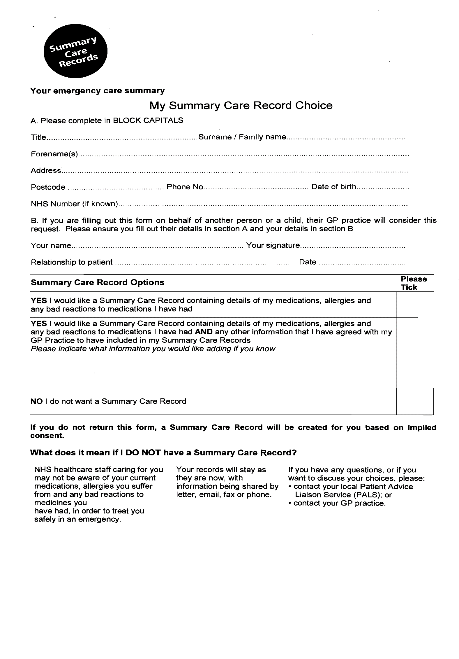

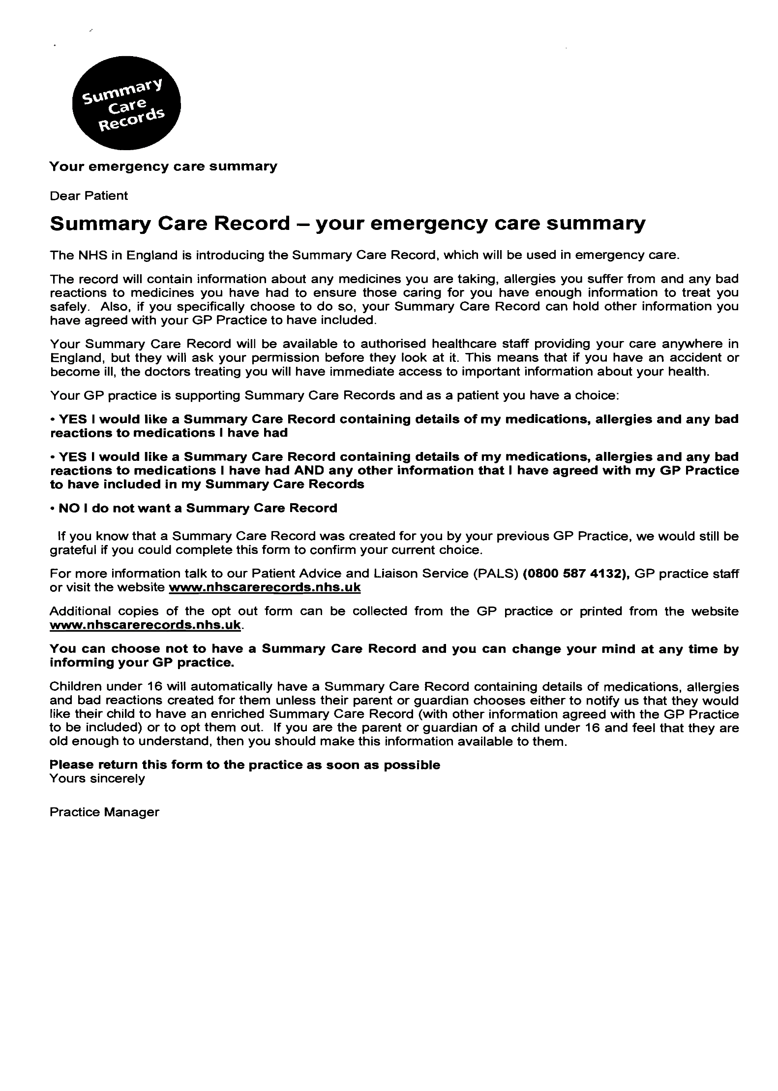

Signing Up For Our Patient Reference Group
If you are happy for us to contact you periodically by email please leave your details below and hand this form in at reception.
Name: …………………………………………………………………………………..
Email Address: ………………………………………………………………………….
Telephone: ………………………………………………………………………….
Postcode: ……………………………………………………………………………
The information below will help to make sure that we receive feedback from a representative sample of the patients registered at this practice.
Your Gender: Male D Female D
Your Age:
Under 16 D 17 -24 D 25 -34 D 35 -44 D 45 -54 D 55 -64 D 65 -74 D 75 -84 D Over 84 D

The ethnic background with which you most closely identify is:
White British Group D Irish D
Mixed White & Black Caribbean D White & Black African D White & Asian D
Asian or Asian British Indian D Pakistani D Bangladeshi D
Black or Black British Caribbean D African D
Chinese or Other Chinese D Any Other D
How would you describe how often you come to the practice?
Regularly D Occasionally D Very rarely D
Thank you
Please note that we will not respond to any medical information or questions received through the survey.
The information you supply us will be used lawfully, in accordance with the Data Protection Act 2018 and GDPR – this gives you the right to know what information is held about you, and sets out rules to make sure that this information is handled properly. Information regarding GDPR and our Privacy Policy can be found on www.thelimesmedicalcentre.com

THE LIMES MEDICAL CENTRE
The Plain, Epping CM16 6TL
01992 573838
weccg.f81043-results@nhs.net
CONSENT TO SHARE INFORMATION WITH A FAMILY MEMBER/
GUARDIAN OR LEGAL EXECUTIVE
Consent is required for patients who wish a family member, guardian or legal executive to have access to their medical records. By signing below, it will give your nominated person the right to have access to appointment information, test results, information about any medication you are taking and any aspects of your current or past health. Once completed, this consent will be scanned into your medical records and a note made that you have given your permission. Our staff will then be happy to talk to the person you nominate. Without a signed form, we are unable to disclose any information for reasons of confidentiality.
__________________________________________ DOB ____________________________
Give consent to:
Name ____________________________________________________
Relationship ____________________________________________________
Address ____________________________________________________
____________________________________________________
____________________________________________________
Telephone ____________________________________________________

CONSENT TO SHARE INFORMATION WITH A THIRD PARTY
External healthcare organisations such as hospitals often contact the practice before upcoming surgery/medical investigations, requesting a Patient Summary. This summary contains basic but necessary information such as medication, allergies, past medical history, and most recent (but relevant) consultations. Without this information, planned surgery or other medical care may be delayed. We need your consent to share your Patient Summary. Please tick the box below stating your preference.

 | Yes | No
I consent to sharing my Patient Summary with a third party

Signed ______________________________ Date __________________________
Print Name ______________________________
_______________________________________________________________________________________
PRACTICE USE ONLY:

Message and date entered onto home page by : _________________________ (Name)

Please pass through for scanning once complete

