A PATIENT’S GUIDE TO REQUESTING MEDICATION
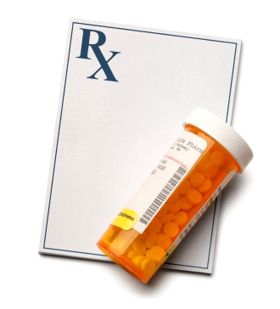

WE UNDERSTAND THAT YOUR MEDICATION IS IMPORTANT TO YOU.
IT IS IMPORTANT THAT YOU OR YOUR CARER(S) ORDERS YOUR MEDICATION(S) UPTO 7 DAYS BEFORE YOU ARE DUE TO RUN OUT
ORDER 5 TO 7 DAYS BEFORE YOU RUN OUT
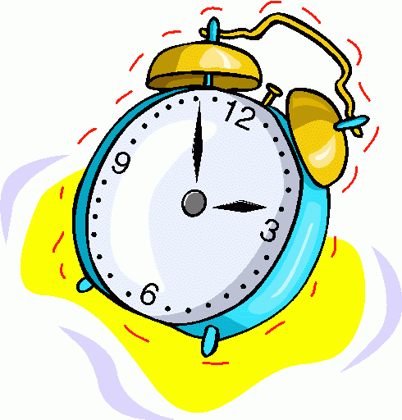
Did you know that you can order your medications in the following ways:
- Online: (simply bring your photo identification to Limes reception and we can issue you a password). Note: This service is only available to patients aged 18 and over
- Repeat slips (WHITE COPY ON THE PRESCRIPTION) can be dropped into our Repeat Prescription Box
- Community Pharmacy (please check the turnaround time with individual pharmacies)

PLEASE NOTE: We will no longer be accepting Telephone Medication Requests.
Out of practice opening hours your community pharmacy may be able to issue you with an Emergency Supply if it is deemed appropriate.
As a practice we endeavor to process your prescription requests within a timely manner and you should allow 48 working hours for routine repeat prescription requests.
Please respect our staff as it is your responsibility to ensure that your repeat prescription request is ordered in plenty of time.
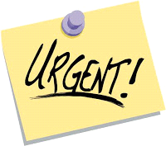
An URGENT prescription request is for medication which you need within 24 hours, to prevent you from becoming severely unwell or becoming pregnant. These include
Type of Medication | Common examples (NOT an Exhaustive List)
Adrenaline Injection | Epipen, Emerade, Jext
Insulin Injections | NovoRapid, Lantus,Levemir, Humalog, Humulin, Insulatard, Actrapid
Anticoagulants | LMWH (Enoxapain/Clexane), Warfarin, NOAC (Apixaban, Rivaroxaban, Dabigatran)
Salbutamol Inhalers | Issue but please book in to see an Asthma Nurse within 4 weeks if using frequently (if Asthmatic and has requested >4 inhalers in last 12 months)
Emergency Contraception  (Morning After Pill) | Please be aware some Community Pharmacies offer this for free, sexual health clinics can provide it or it can be purchased over the counter (“OTC”) e.g. Levonelle (within 72hrs), ellaOne (within 120hrs)
Antiepileptics | (Please note some of these medications may have alternative indications for use) Carbamazepine, Phenytoin, Gabapentin, Sodium Valproate
Antihypertensives | Bisoprolol, Ramipril, Amlodipine, Losartan, Indapamide, Doxazosin etc
GTN sprays and 300mcg tablets for Angina are P medicines which can be purchased from the pharmacy
COMMONLY ASKED QUESTONS ABOUT YOUR MEDICATION

WHAT IF………

- You are away from home but registered with a GP elsewhere in England and have run out of your medication(s)? You should contact your own GP and request that a prescription is sent electronically to a pharmacy nearby.

- You have run out of your medication(s) and it is outside of normal GP working hours? You may be able to obtain an Emergency Supply from your regular community pharmacy. (Note: Charges may apply).

- You have been given a new medication by another organisation e.g. hospital or privately? For us to prescribe your medication, we require a discharge summary or clinic letter i.e. written confirmation of the changes to your medication Please note that some medications may require monitoring/or is specialist so may not be appropriate for us to prescribe. Consequently we may not be able to process the request until we can verify the changes.

PRESCRIBING FOLLOWING A PRIVATE CONSULTATION:

- If you choose to be seen privately by a Specialist or GP, any recommended medication to be prescribed will need to be paid for privately i.e. the cost of any medication will be paid for by you (the patient).

- If the GP deems the ongoing supply of medication on the NHS to be clinically appropriate/necessary, it should be prescribed in accordance with national/local guidance/policy/joint formulary where available.

- Specialist drugs recommended after a private consultation will not be prescribed on the NHS in West Essex e.g. clomifene citrate (infertility). In most cases these drugs will be classified as RED / hospital only drug list. The prescribing of RED / hospital only drugs will remain the responsibility of the private or NHS specialist.

- For more information on NHS and Private Care see NHS Choices; https://www.nhs.uk/chq/Pages/2572.aspx?CategoryID=96

OVER THE COUNTER MEDICATION:
West Essex CCG Guidance on medications that should be purchased from a pharmacy by patients:
https://westessexccg.nhs.uk/your-health/medicines-optimisation/general-prescribing-guidance/over-the-counter-medication-otc/patient-information/3611-self-care-aware/file

PHARMACY ADVICE
If you have any queries about your medication, please contact the Limes Medical Centre on
01992 573838; please ask for our Clinical Pharmacists.

